**Task 5:**

**Title:** **Deploy to EC2 Instance SSH into an AWS EC2 instance. Pull Docker image from Docker Hub. Run the container and expose it on port 80 or 8080**  
**Your Name:** Ujjawal Rawat  
**Date:** 06-Oct-2025

**Task Objective**

**Title:** Task Overview  
**Task:**

* Deploy to EC2 Instance
* SSH into an AWS EC2 instance
* Install Docker
* Pull Docker image from Docker Hub
* Run the container and expose it on port **80** or **8080**

**Outcome:**

* Application running on cloud and accessible via browser

**Tools & Technologies**

* **AWS EC2** → Cloud server
* **Docker** → Container platform
* **SSH** → Remote access
* **Docker Hub** → Image repository

**Visual:** Icons for AWS, Docker, SSH

**Step 1 – SSH into EC2**

**Command:**

ssh -i "your-key.pem" ubuntu@<EC2-Public-IP>

**Explanation:**

* Access your EC2 instance using SSH
* your-key.pem → private key file
* <EC2-Public-IP> → public IP of EC2

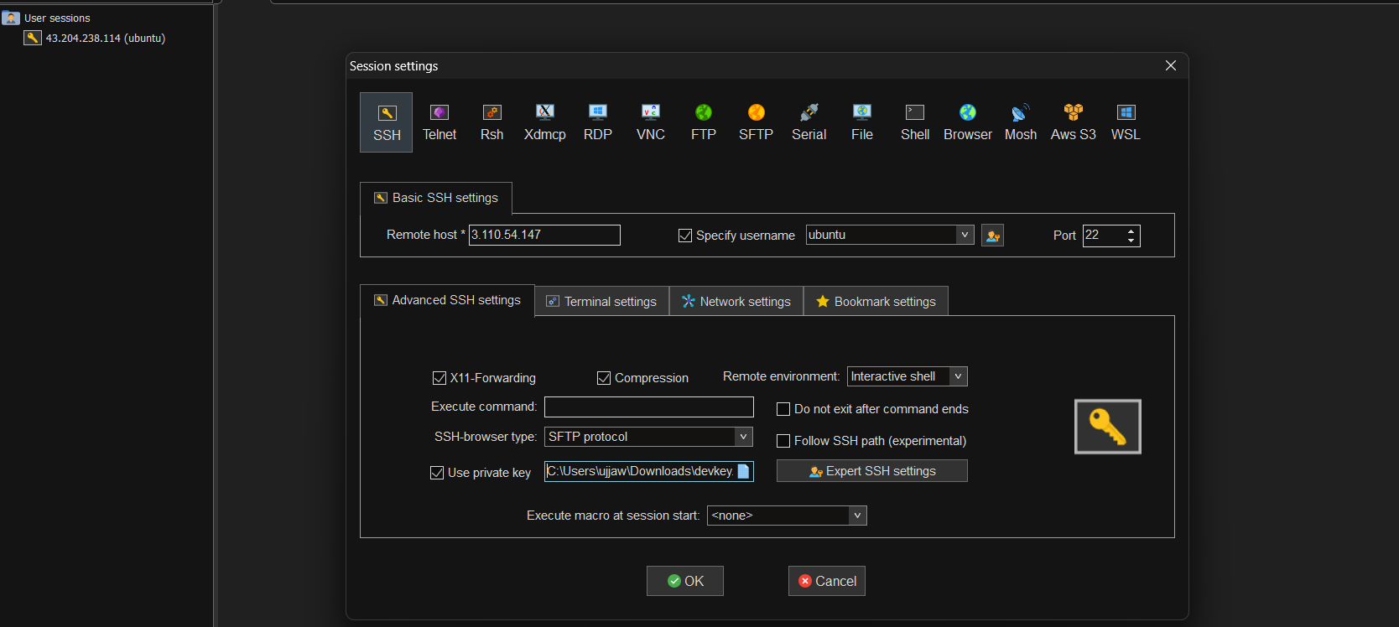

**Step 2 – Install Docker**

**Commands:**

sudo apt update

sudo apt install -y docker.io

sudo systemctl start docker

sudo systemctl enable docker

sudo docker --version

**Explanation:**

* Updates system packages
* Installs Docker
* Starts and enables Docker service to run on boot
* Verifies Docker installation

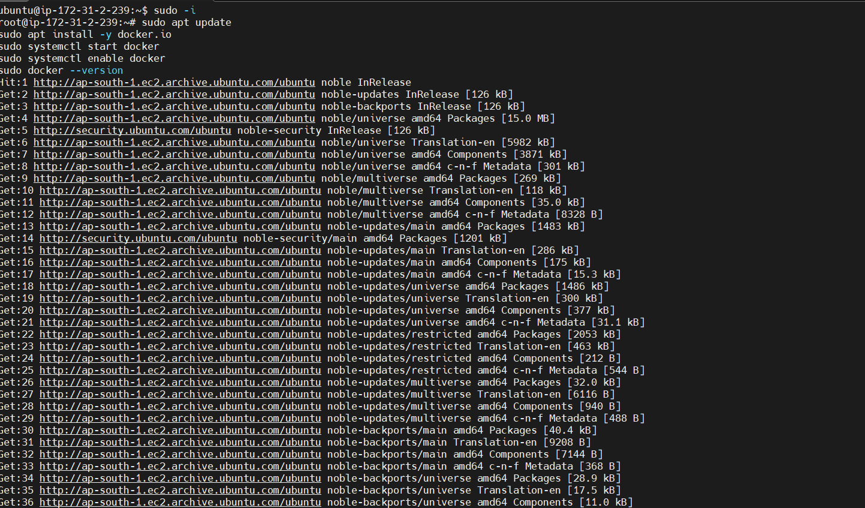

**Step 3 – Pull Docker Image**

**Command:**

sudo docker pull nginx

**Explanation:**

* Pulls the Docker image (nginx) from Docker Hub

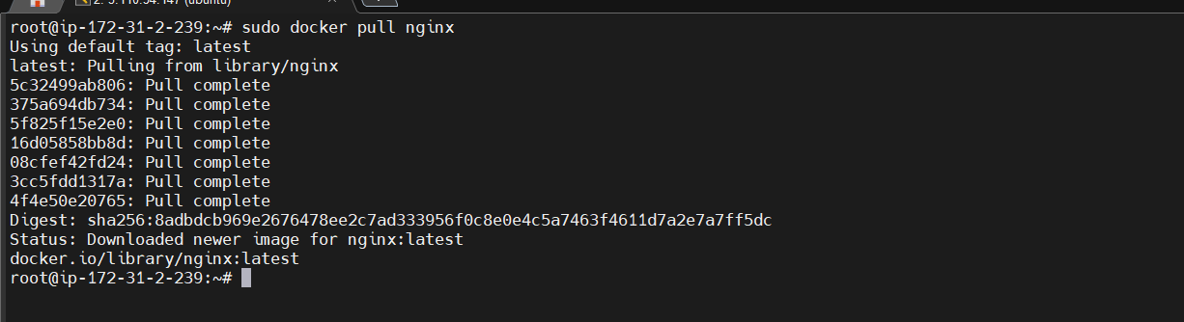

**Step 4 – Run Container and Expose Port**

**Command:**

sudo docker run -d -p 80:80 nginx

**Explanation:**

* Runs container in detached mode (-d)
* Maps EC2 port **80** to container port **80** (-p 80:80)
* Optional: Use port **8080** instead:

sudo docker run -d -p 8080:80 nginx



**Verify running container:**

sudo docker ps



**Step 5 – Access Application**

* Open your browser →

http://<EC2-Public-IP>

* 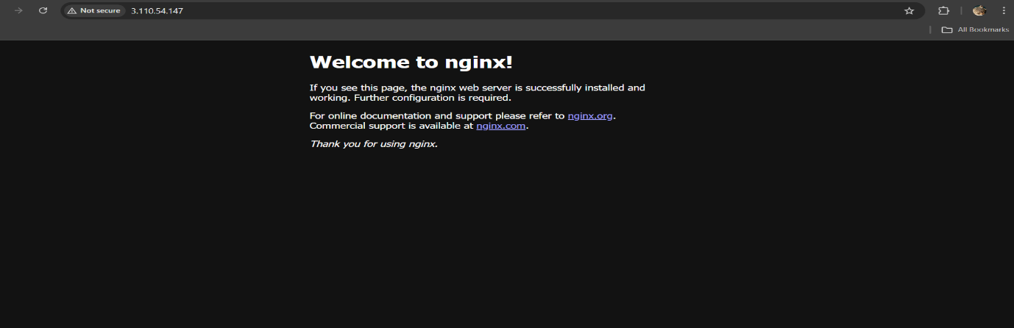You should see the **Nginx default welcome page**

**Summary**

**Task Completed:**

1. SSH into AWS EC2 instance
2. Installed Docker
3. Pulled Docker image from Docker Hub
4. Ran the container and exposed it on port 80 or 8080
5. Verified application in browser

**Outcome:**

* Dockerized application successfully deployed on EC2

**Visual:** Flow diagram: EC2 → Docker → Nginx → Browser